**DEPLOY JAR TO NEXUS USING JENKINS PIPELINE:**

**PREQUISITES:**

1. **Install Jenkins in one Ec2 server--- name it as Jenkins Master**
2. Install java

yum install java-17 -y

yum install docker -y

systemctl start docker

systemctl enable docker

docker run -d -p 8080:8080 -p 50000:50000 jenkins/jenkins:lts

1. **Install Nexus in Another Ec2 server: t**

**Nexus works on t2.large**

**Delete Artifacts in Nexus Repository for every new build otherwise it through the error.**

a) #!/bin/bash

sudo su -

yum update -y

yum install docker -y

systemctl start docker

systemctl enable docker

docker run -d -p 8081:8081 --name nexus sonatype/nexus3

1. **Connect this nexus server to jenkins master --- nexus server act as a jenkins slave**

Install java

yum install java-17 -y

yum install git -y

yum install maven -y

curl -sO http://3.110.92.209:8080/jnlpJars/agent.jar

java -jar agent.jar -url http://3.110.92.209:8080/ -secret 7cc71cd20163ae6749af44e5ead385c8dfc7b220990fce3c6553ac9ede4dced5 -name "slave-1" -workDir "/home/ec2-user/"

**Plugins Required:**

1. Nexus Artifact Uploader
2. Maven Integration

Go to manage Jenkins – tools -add maven – name -maven

Apply-save

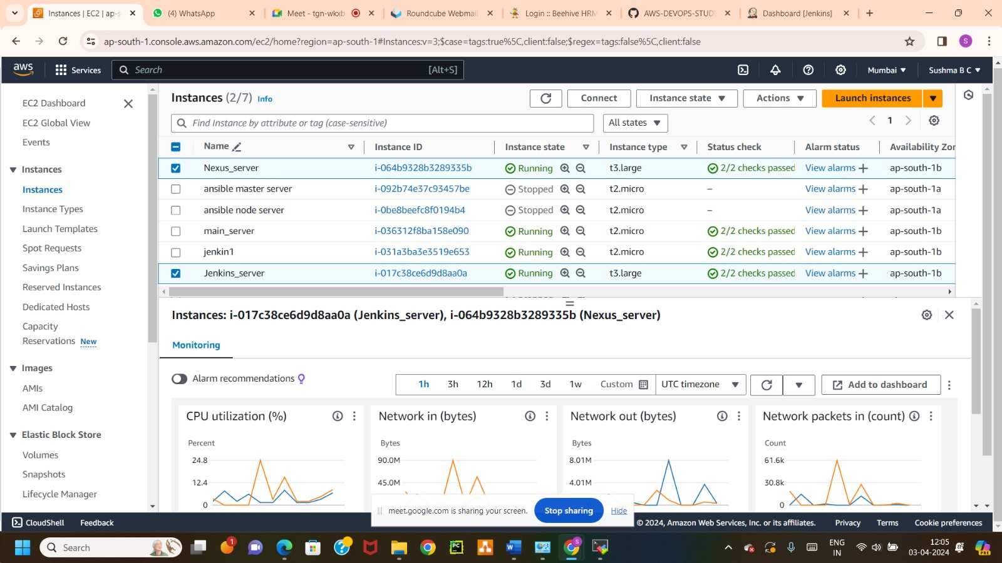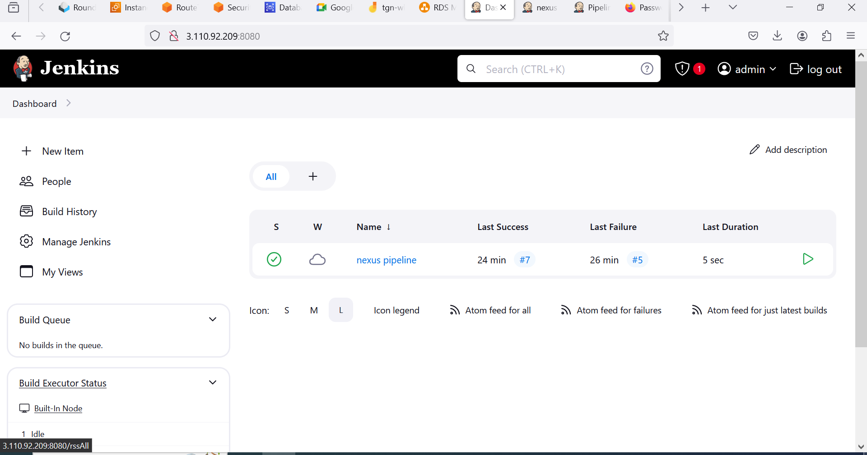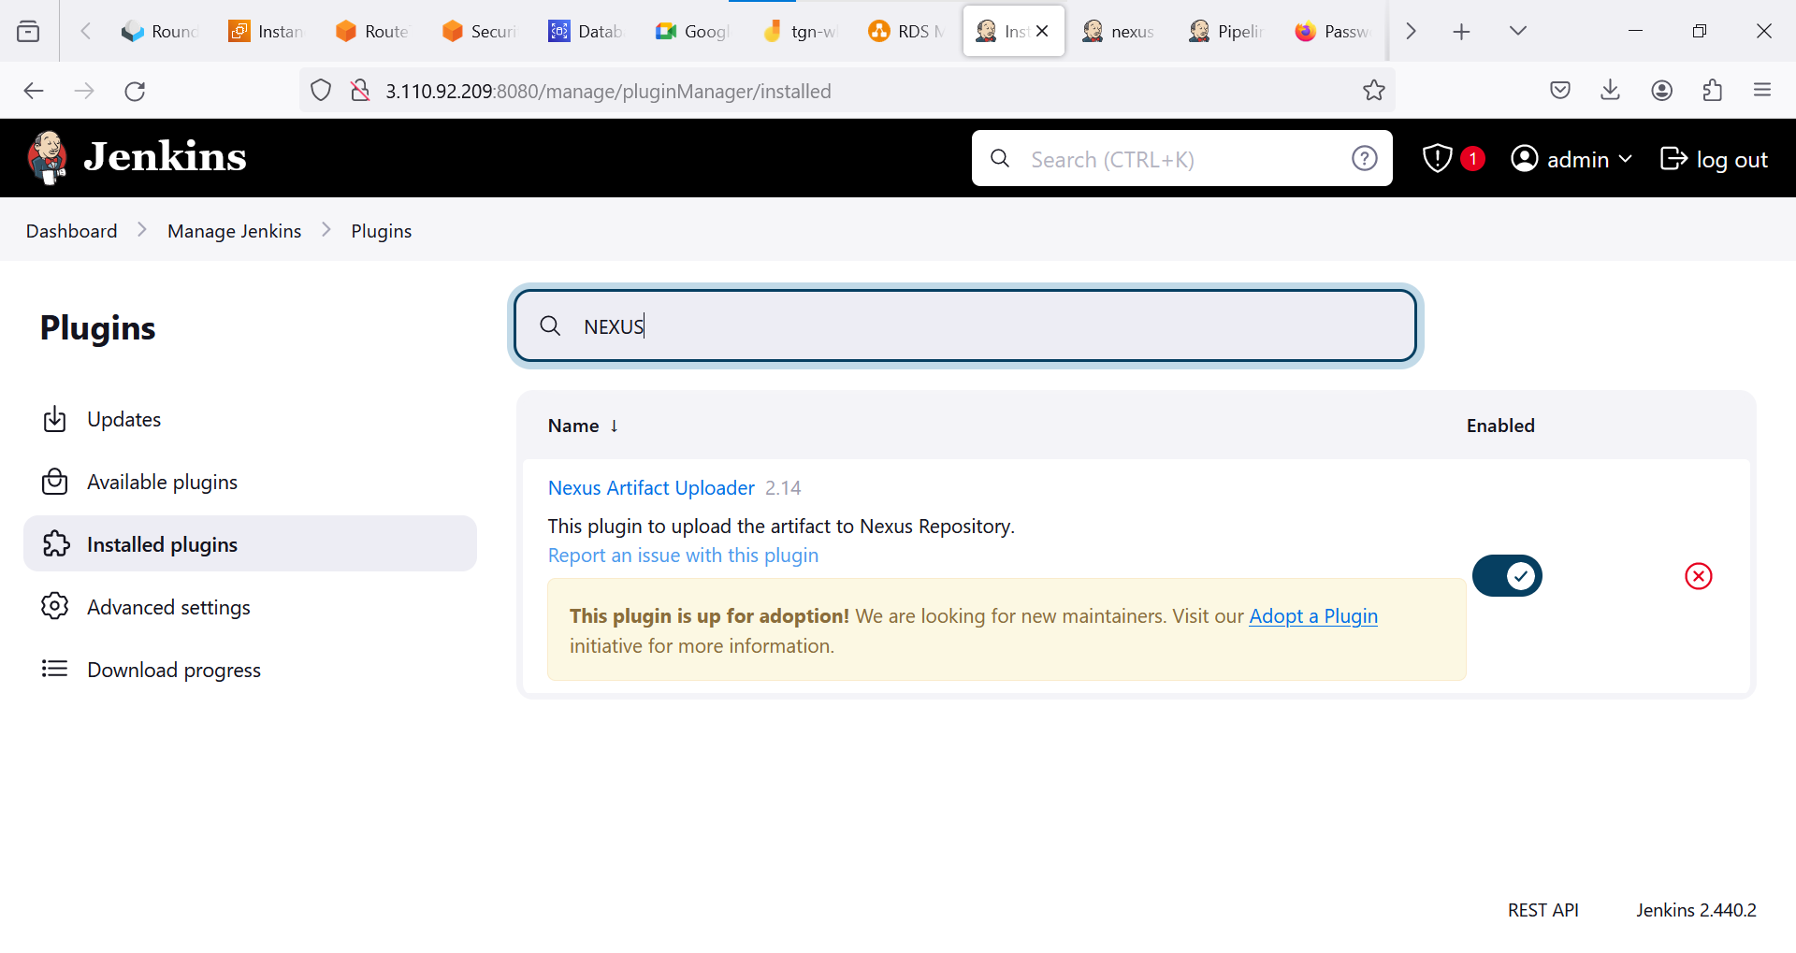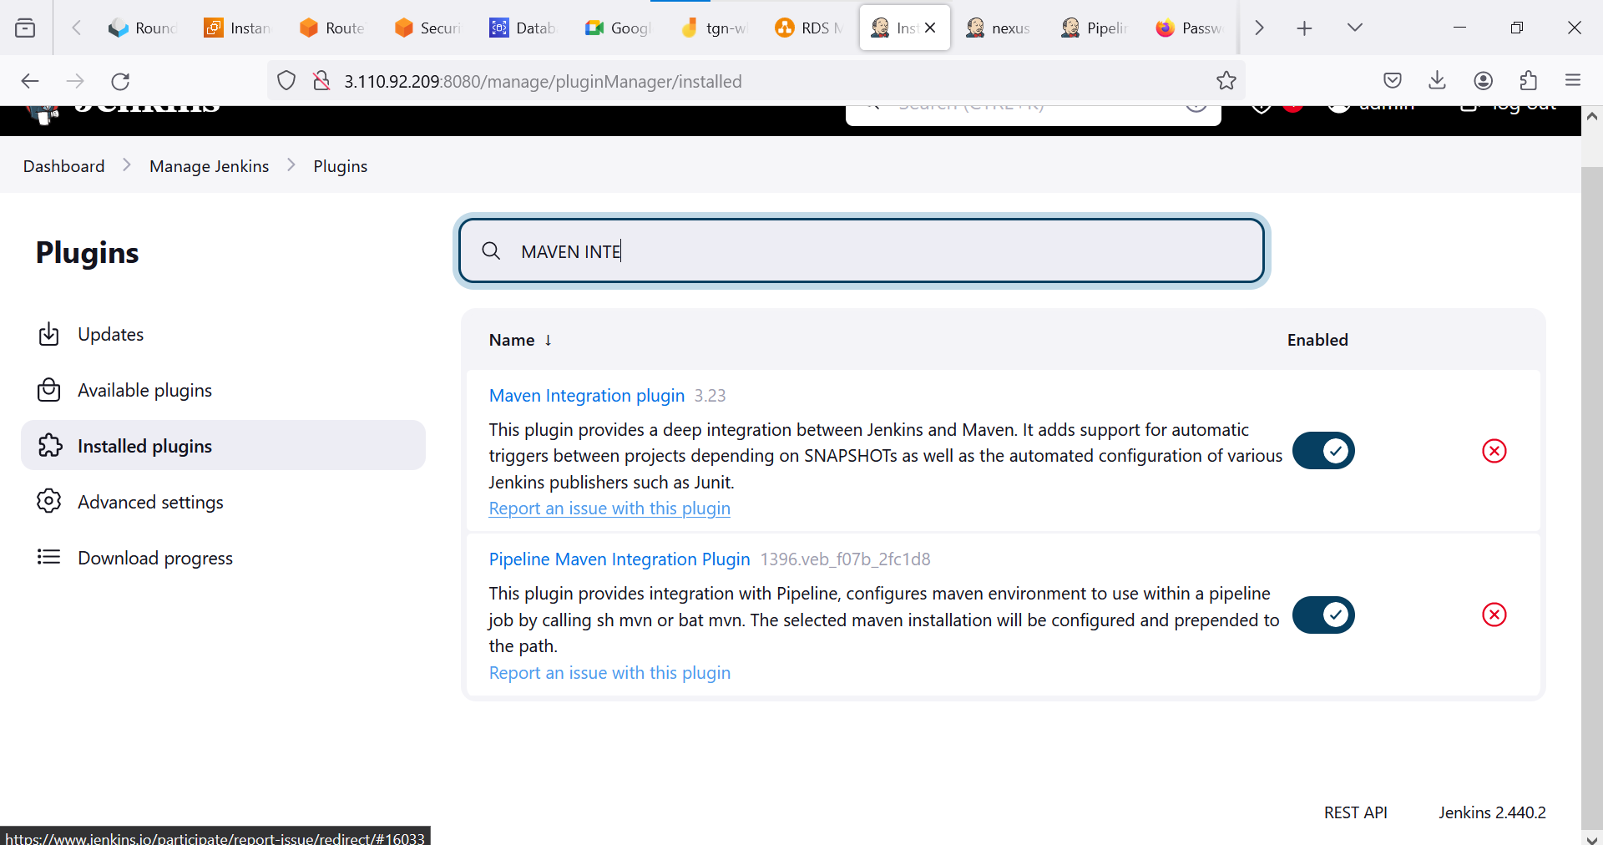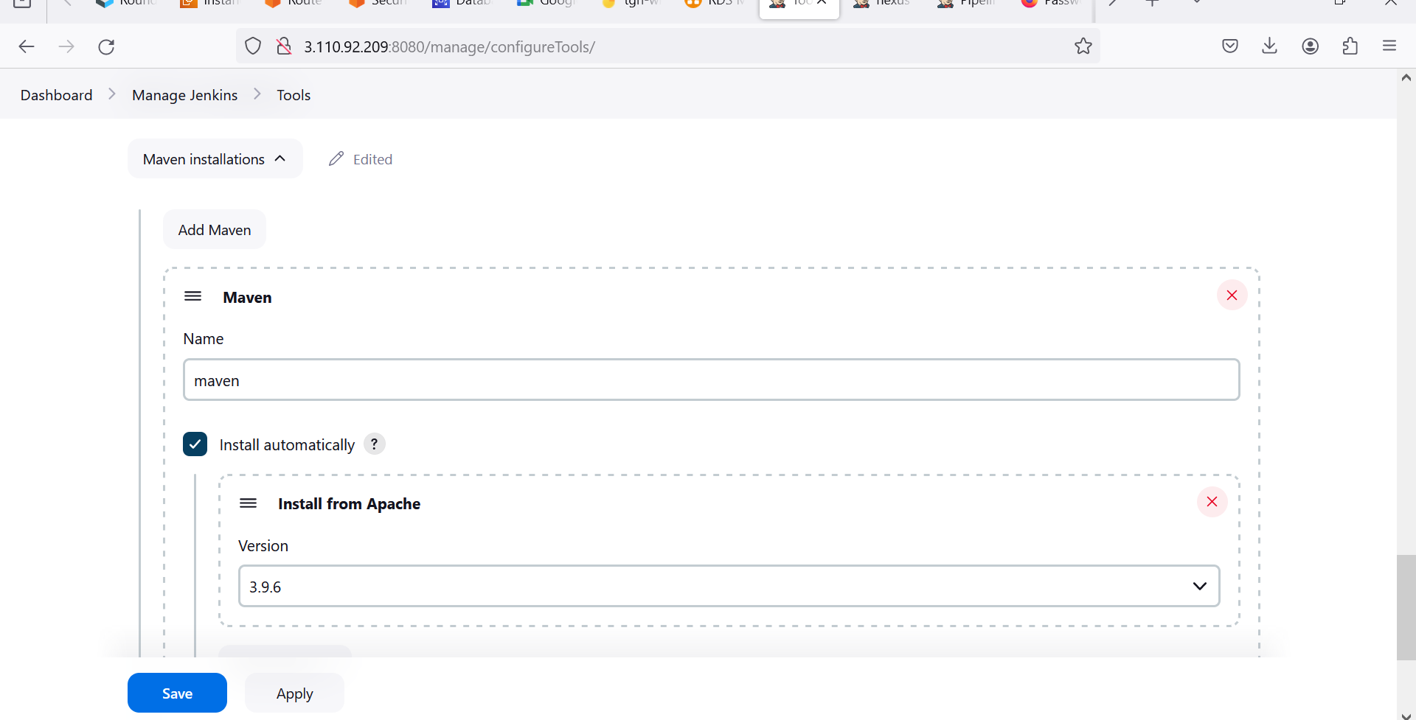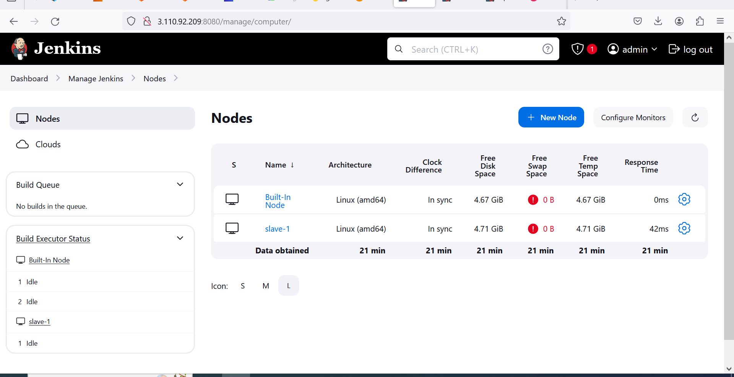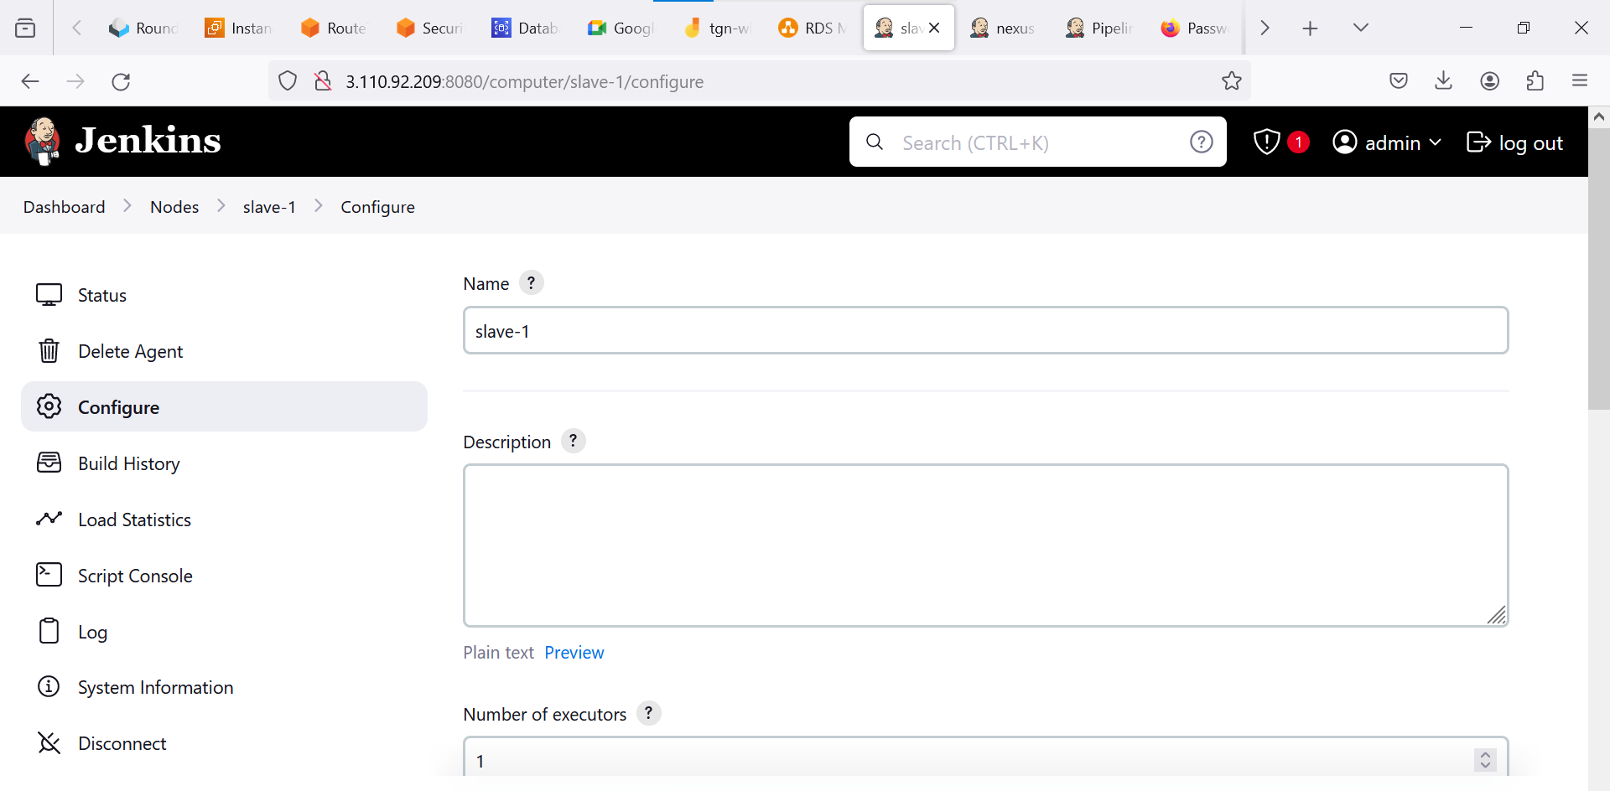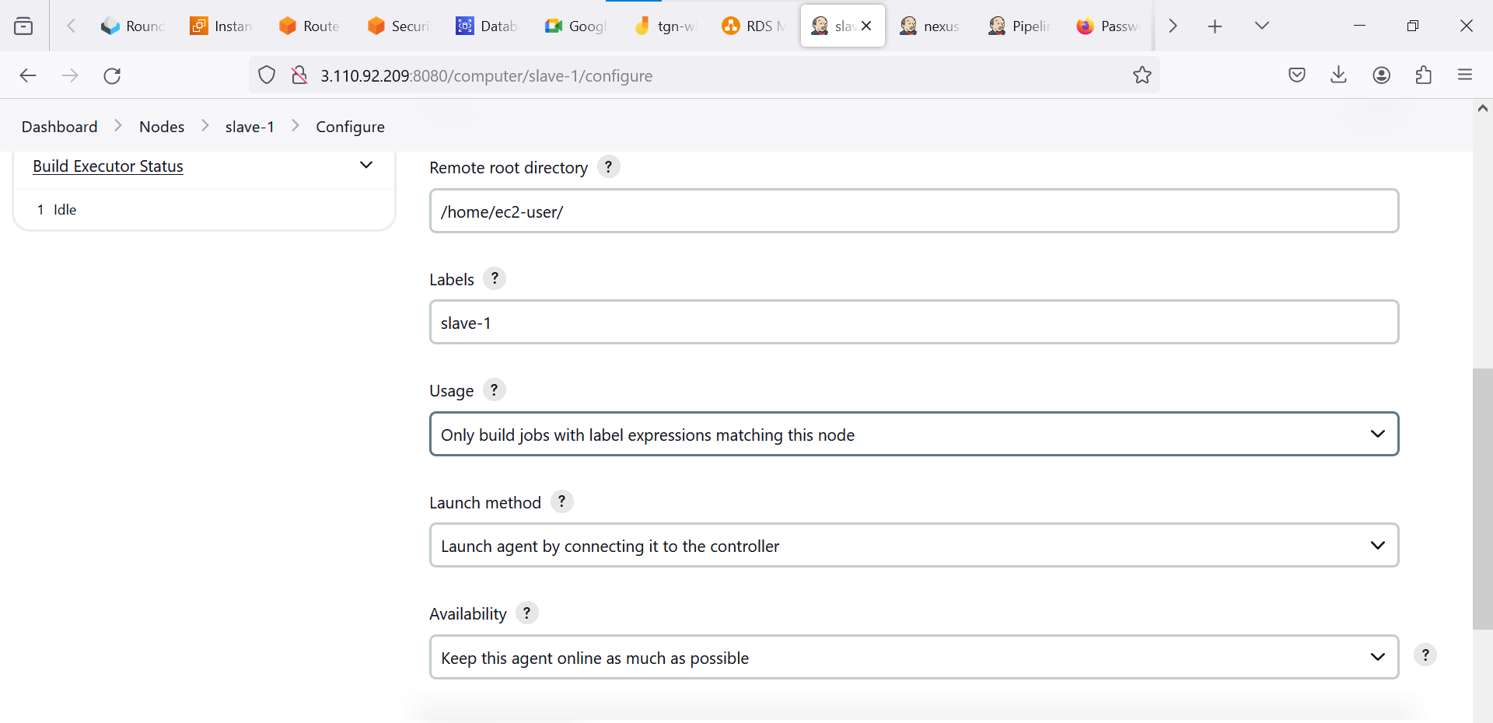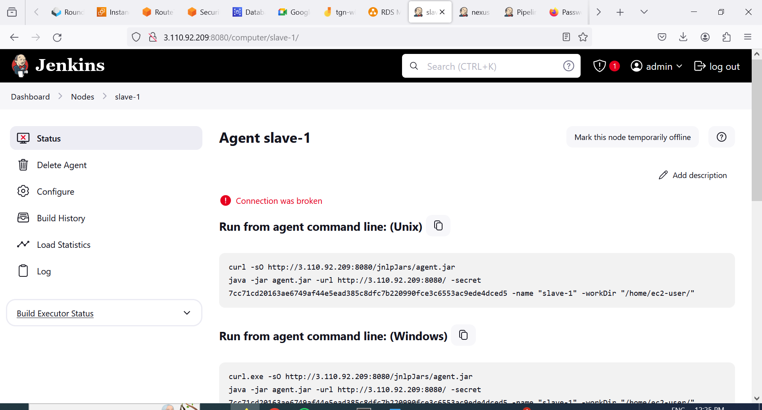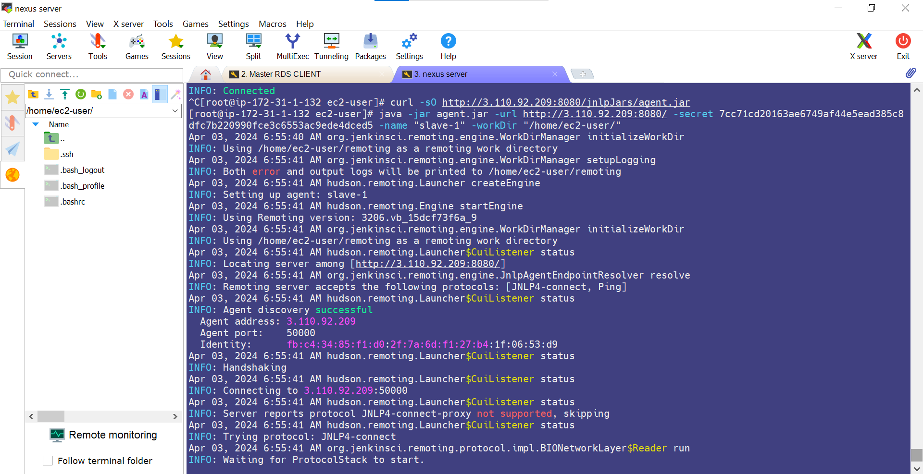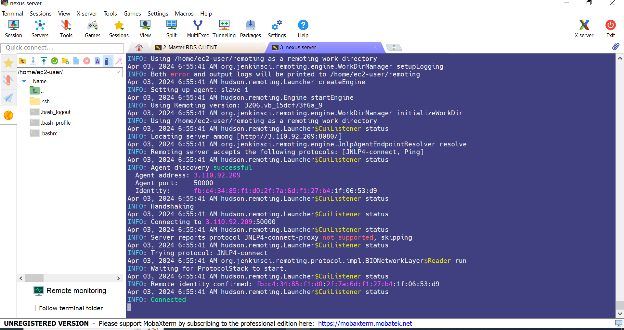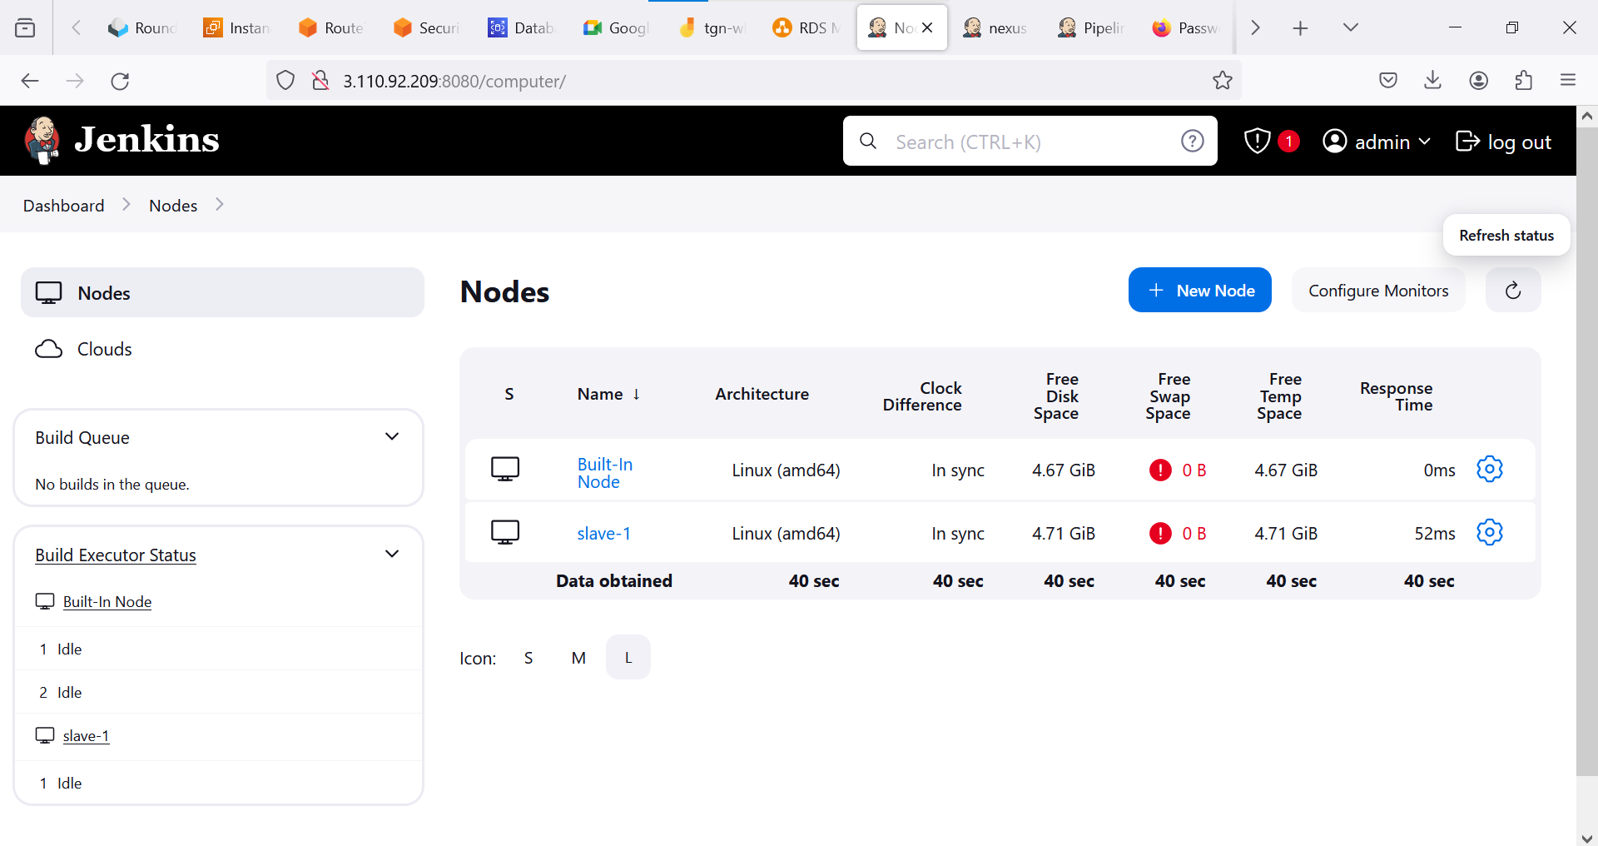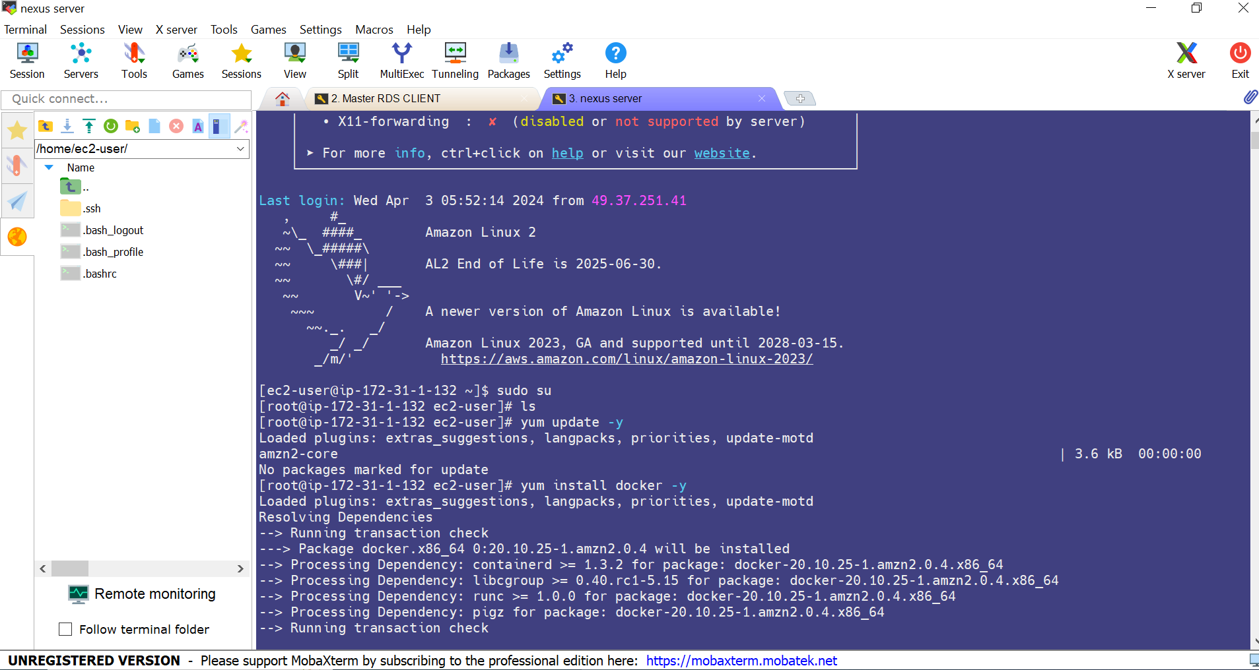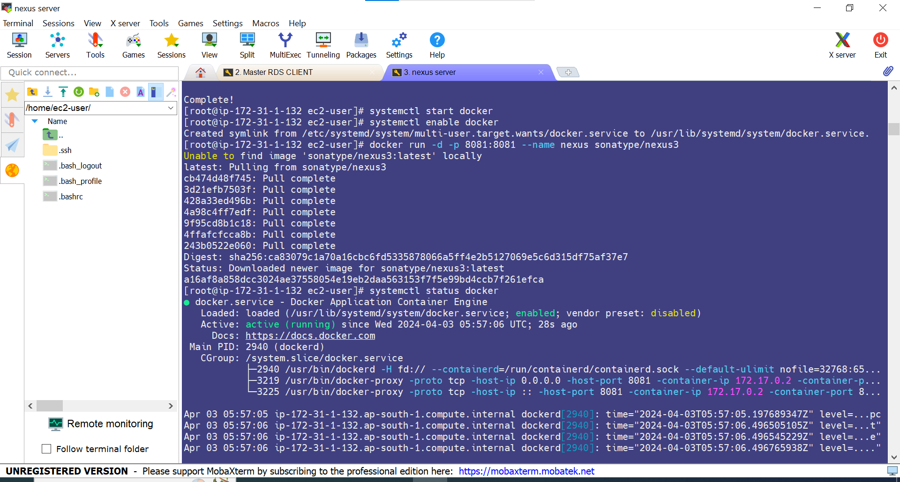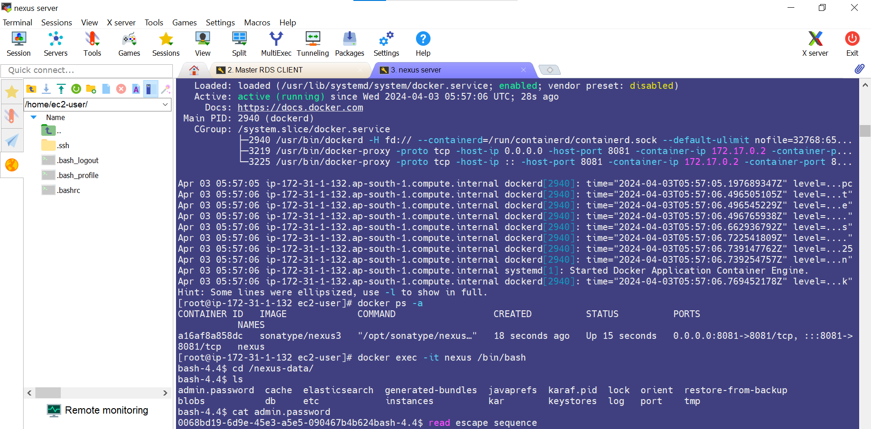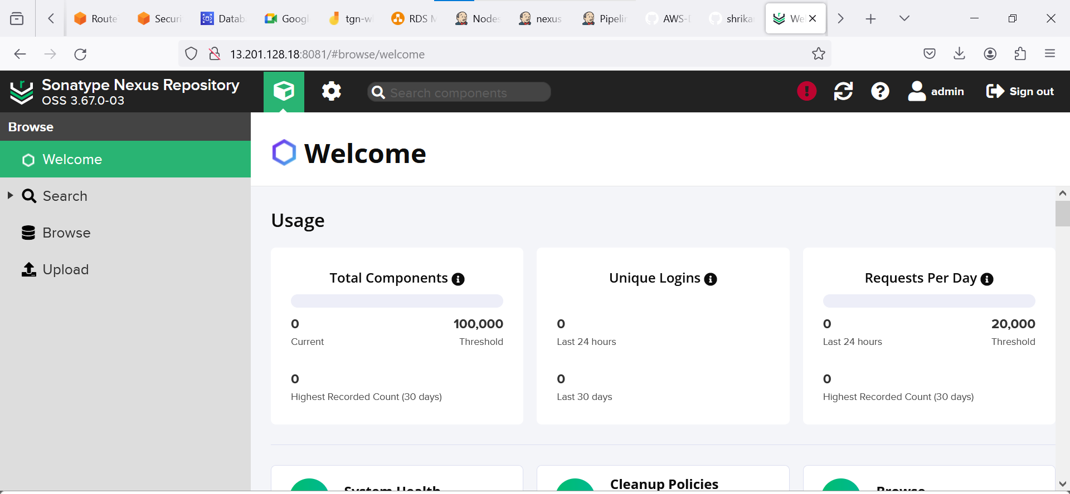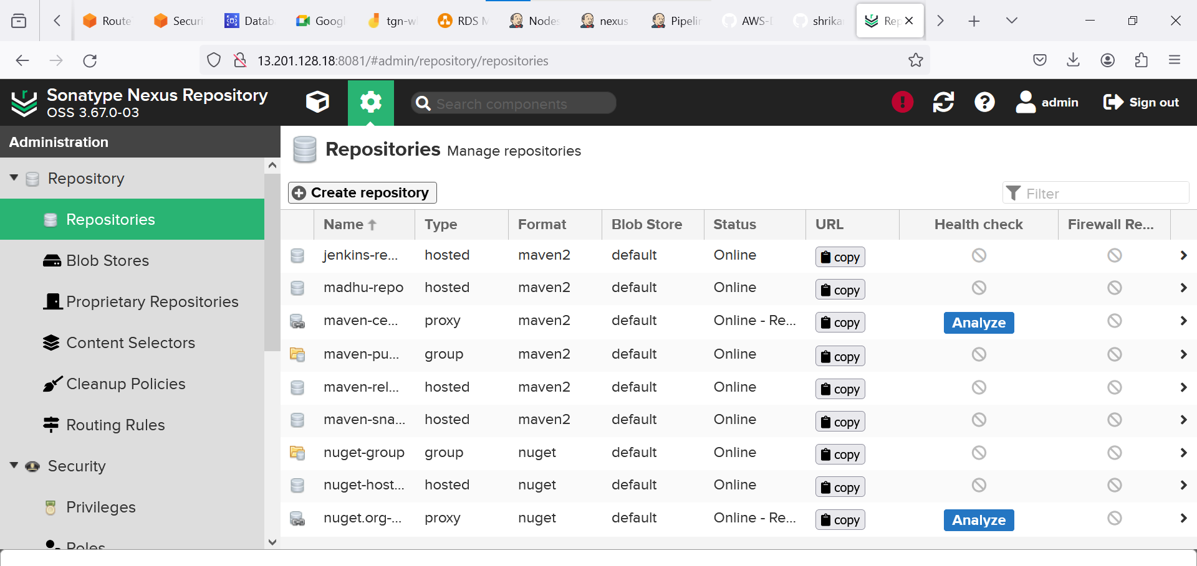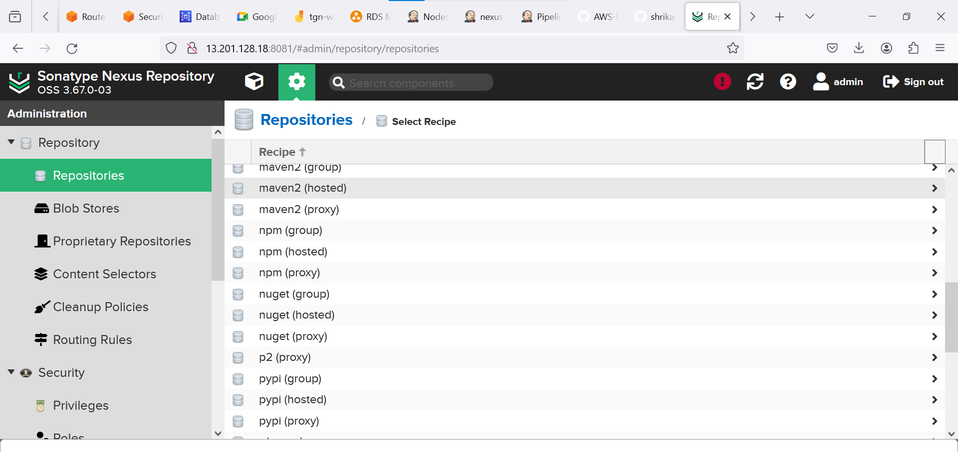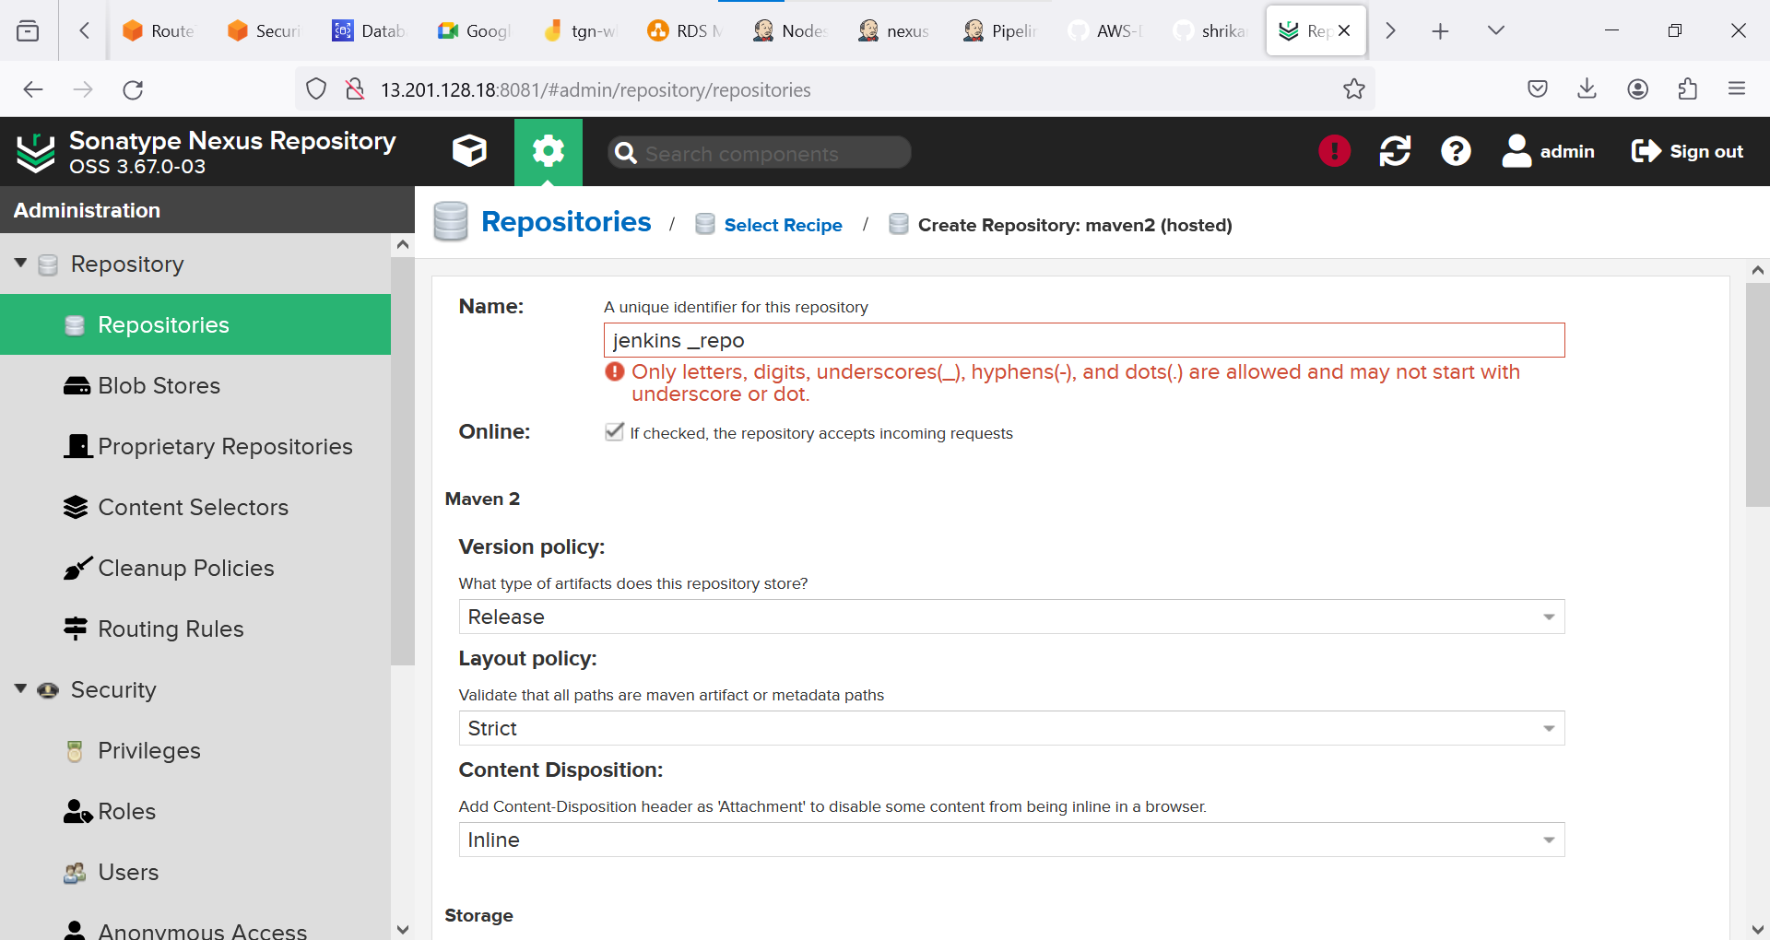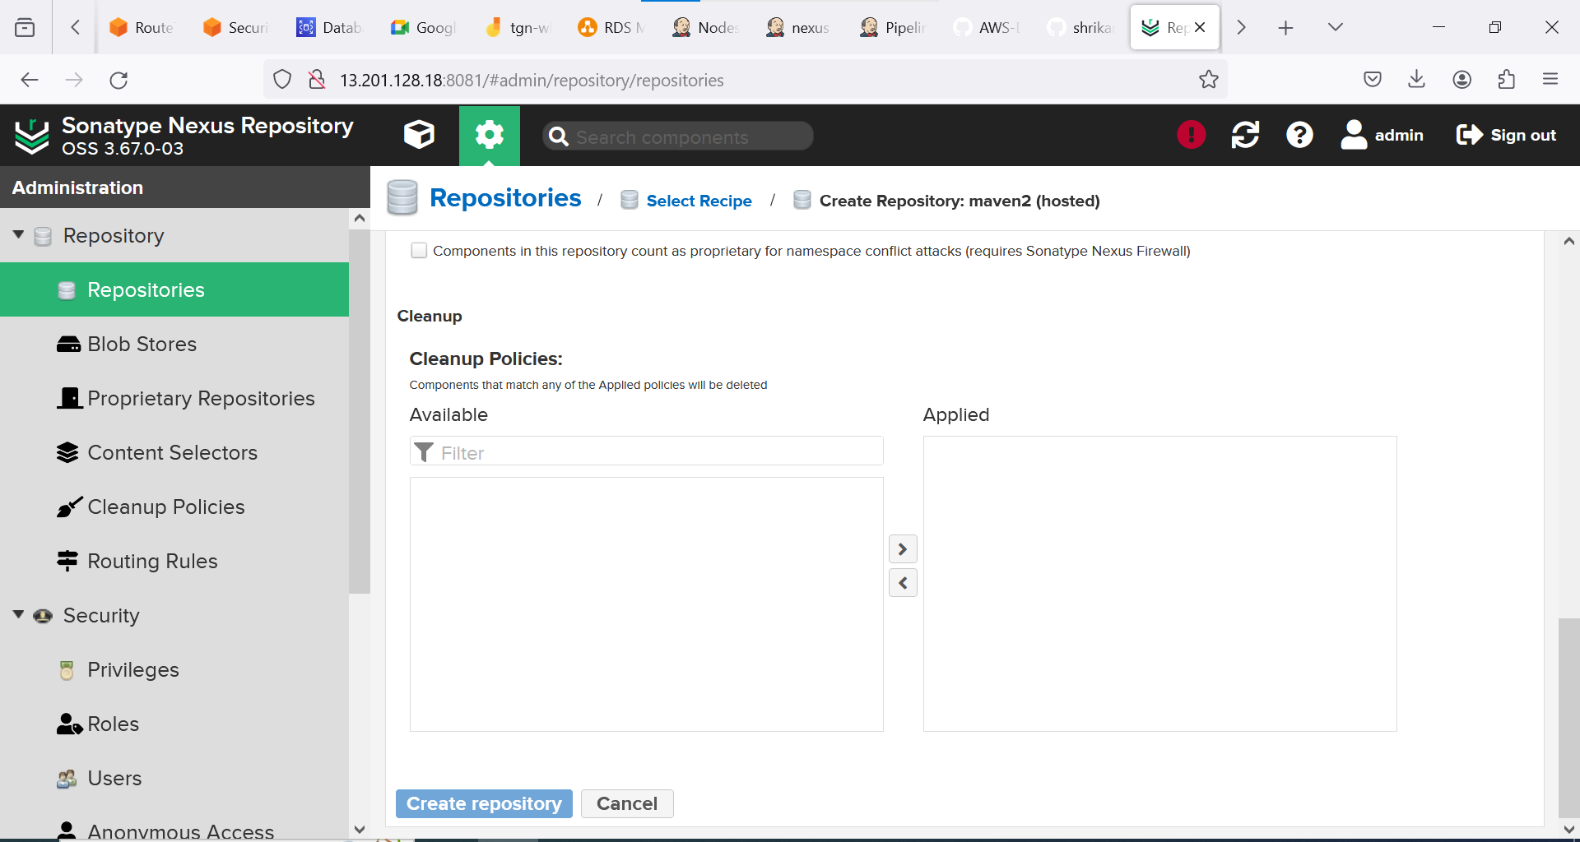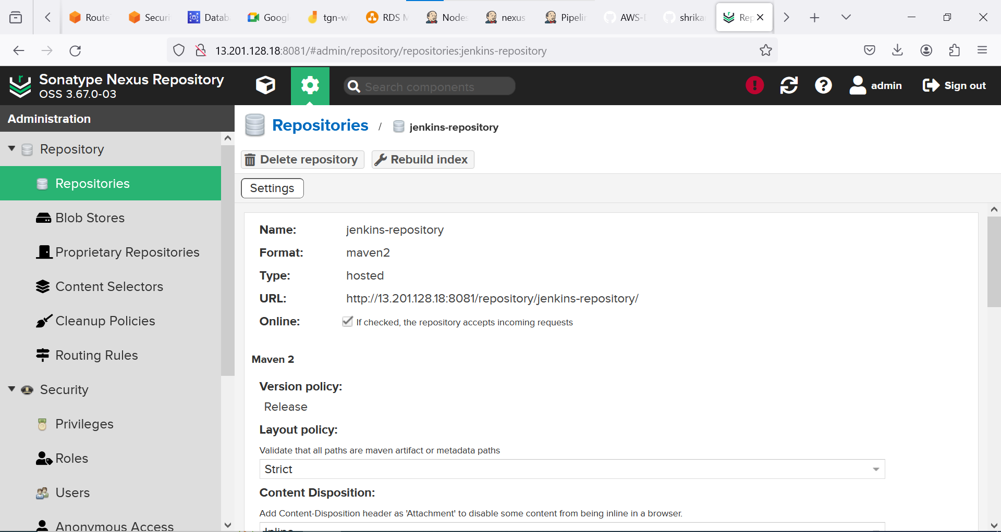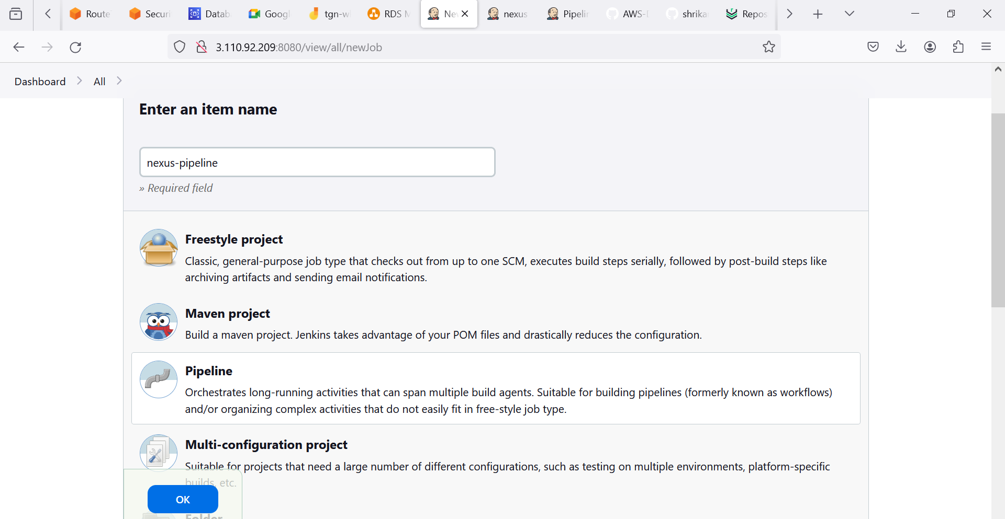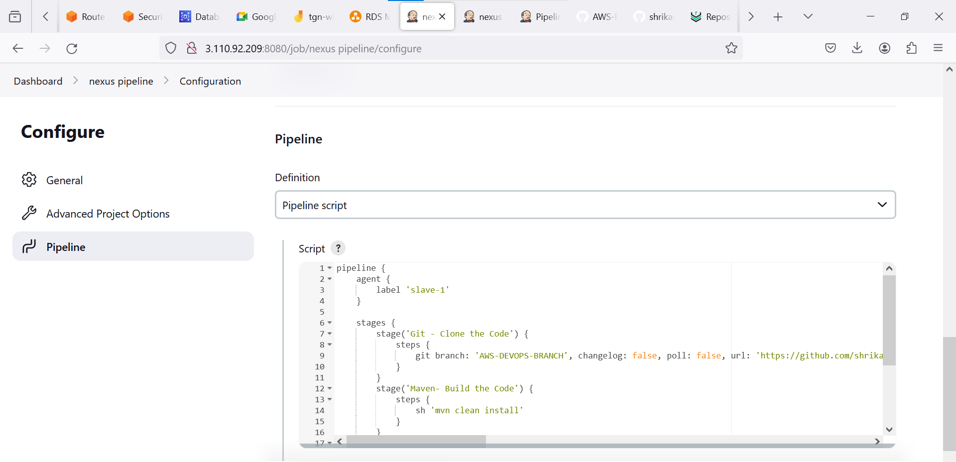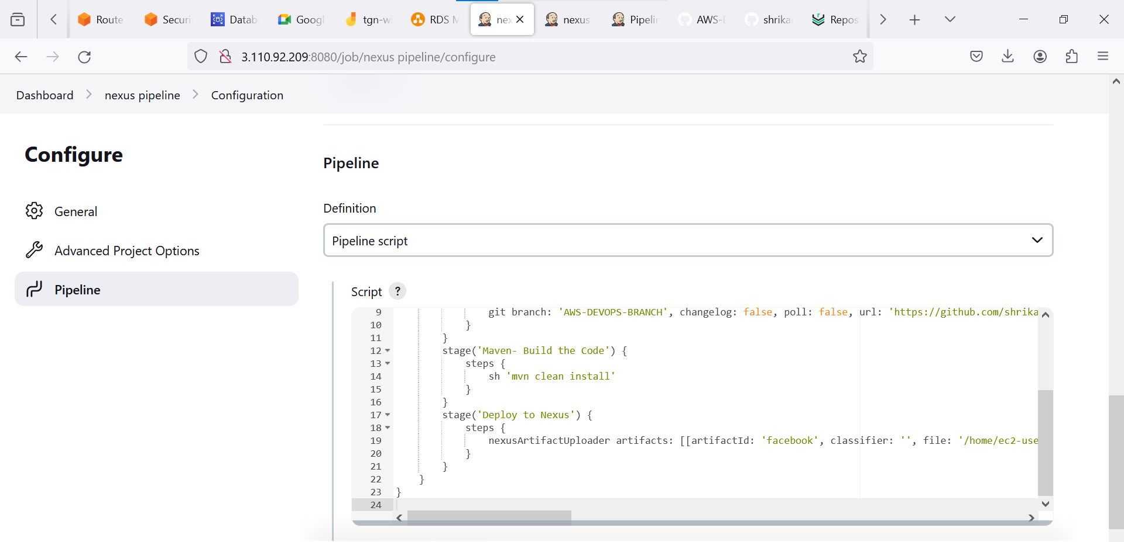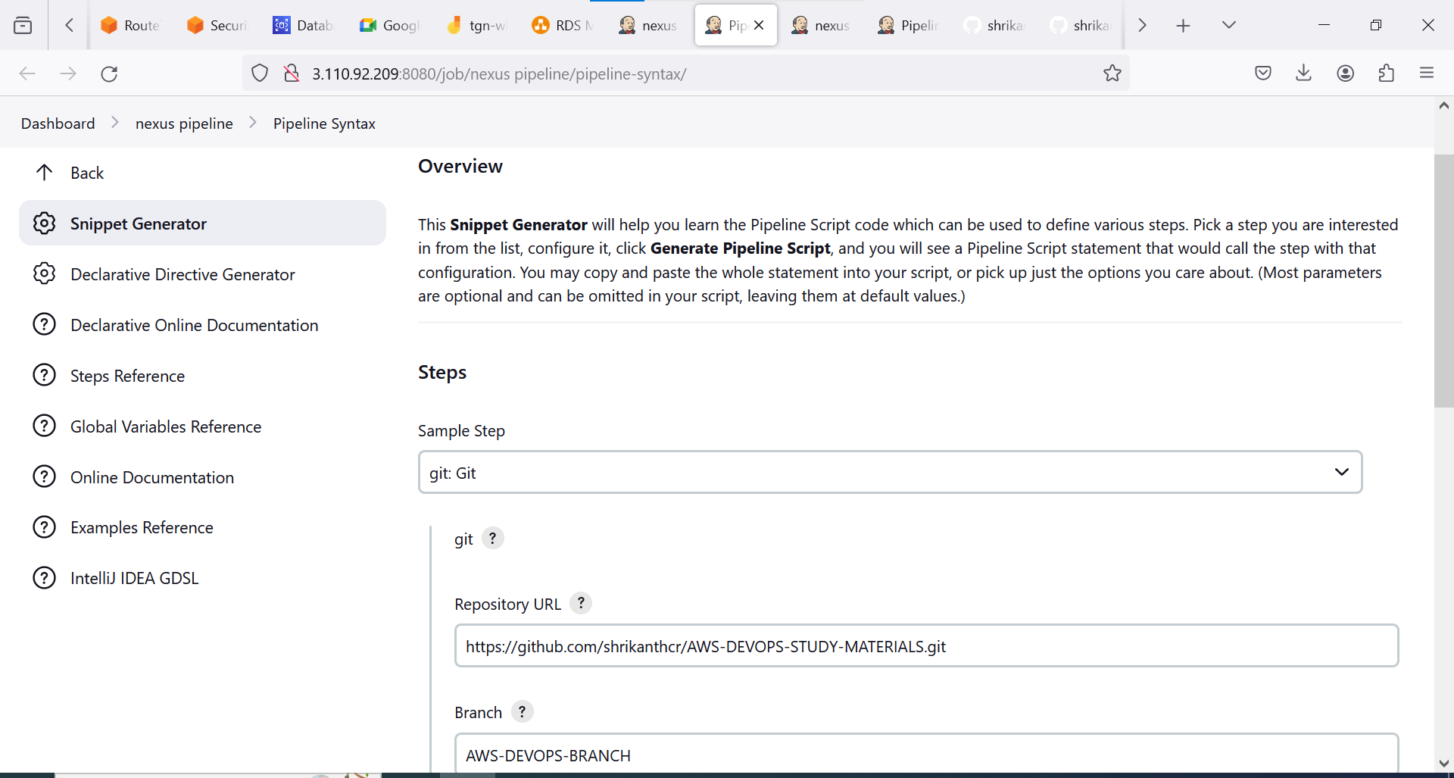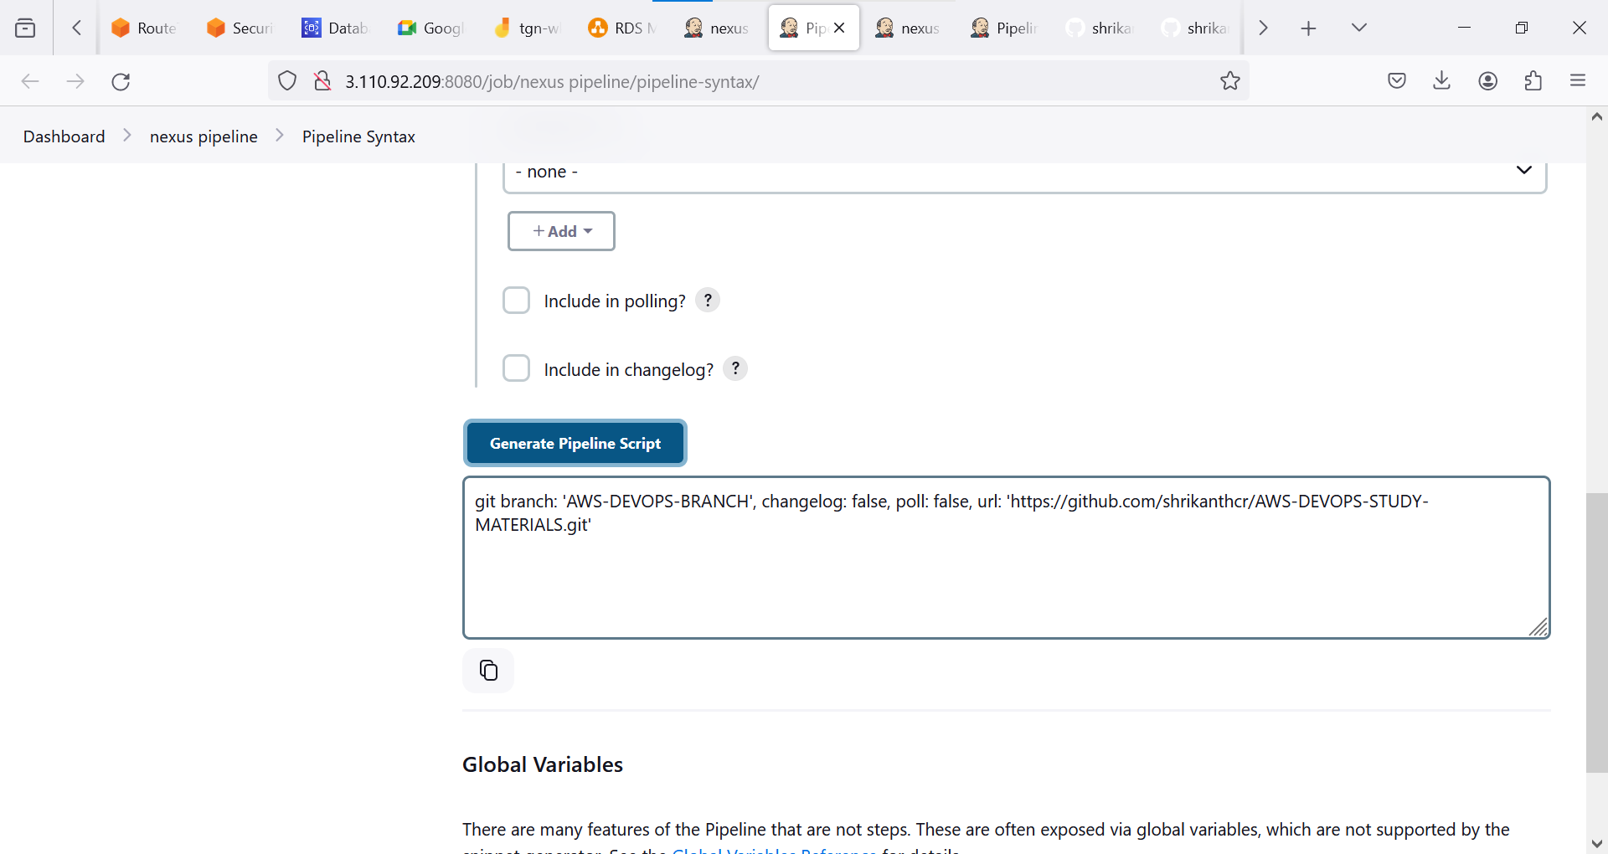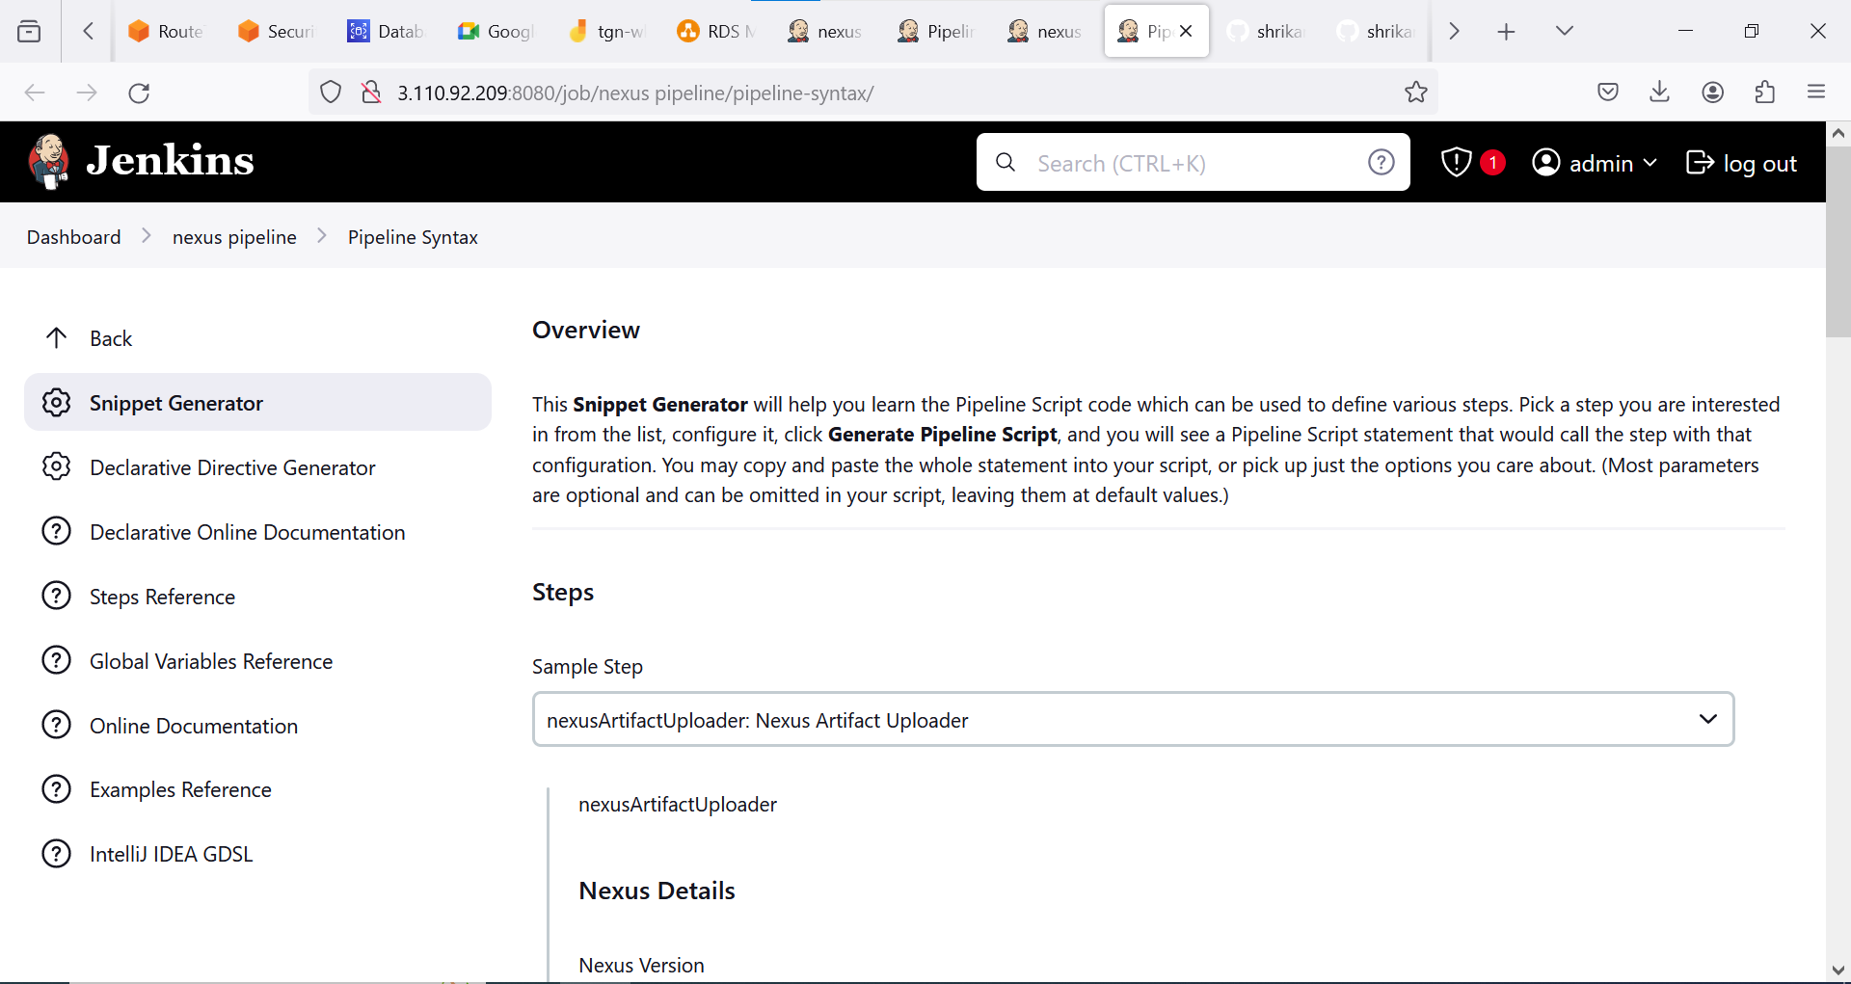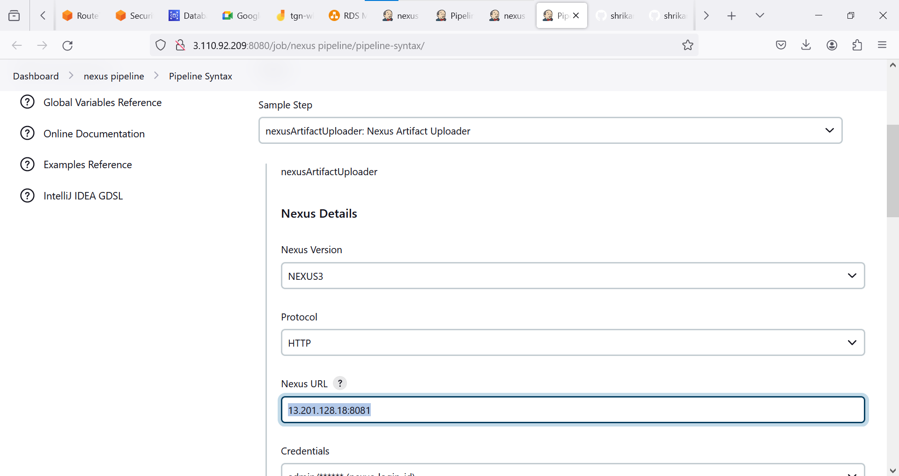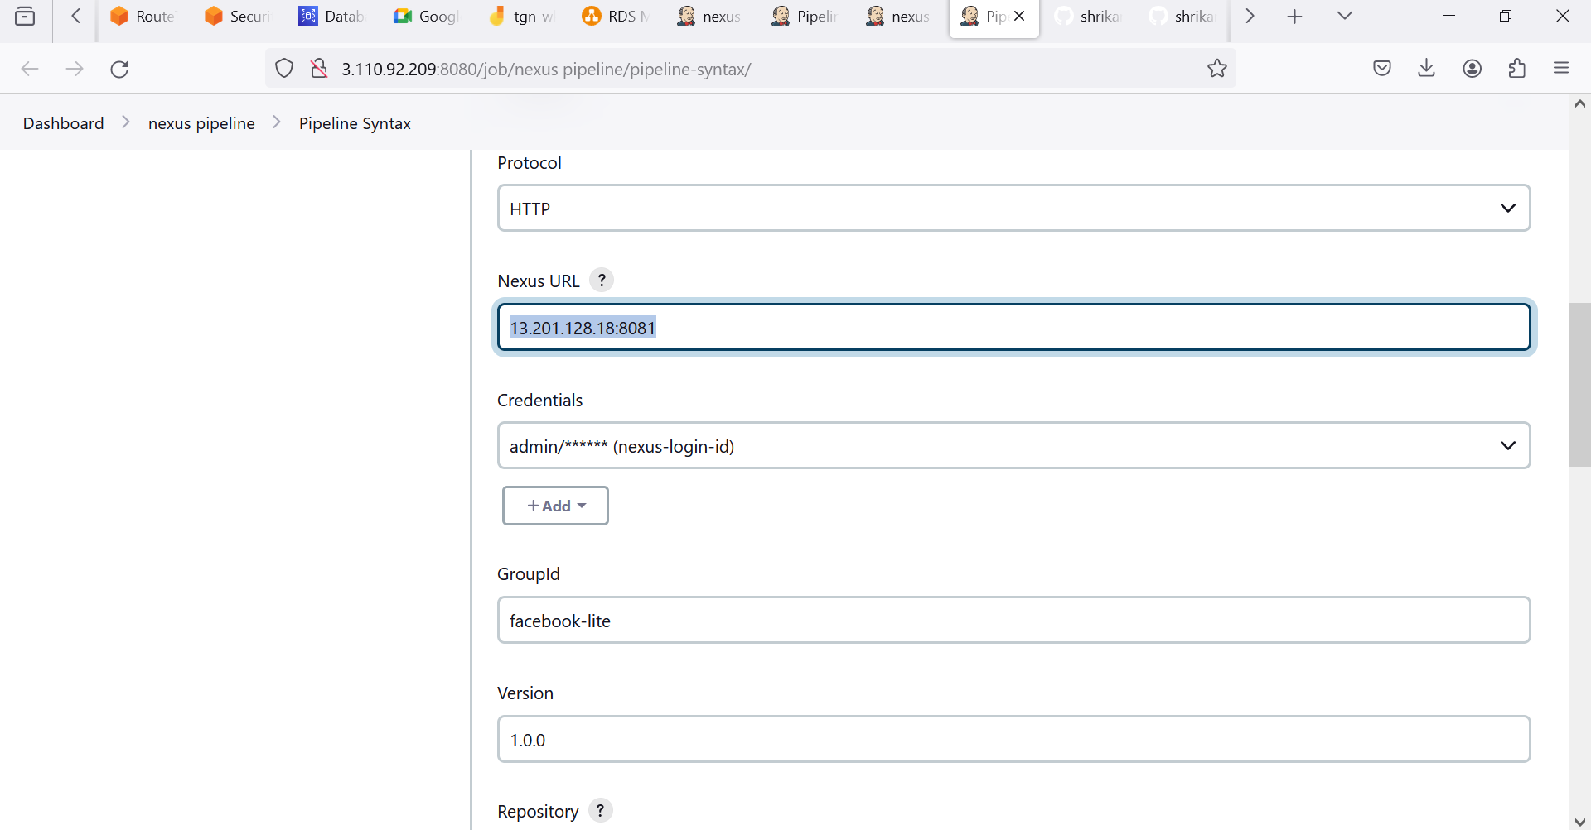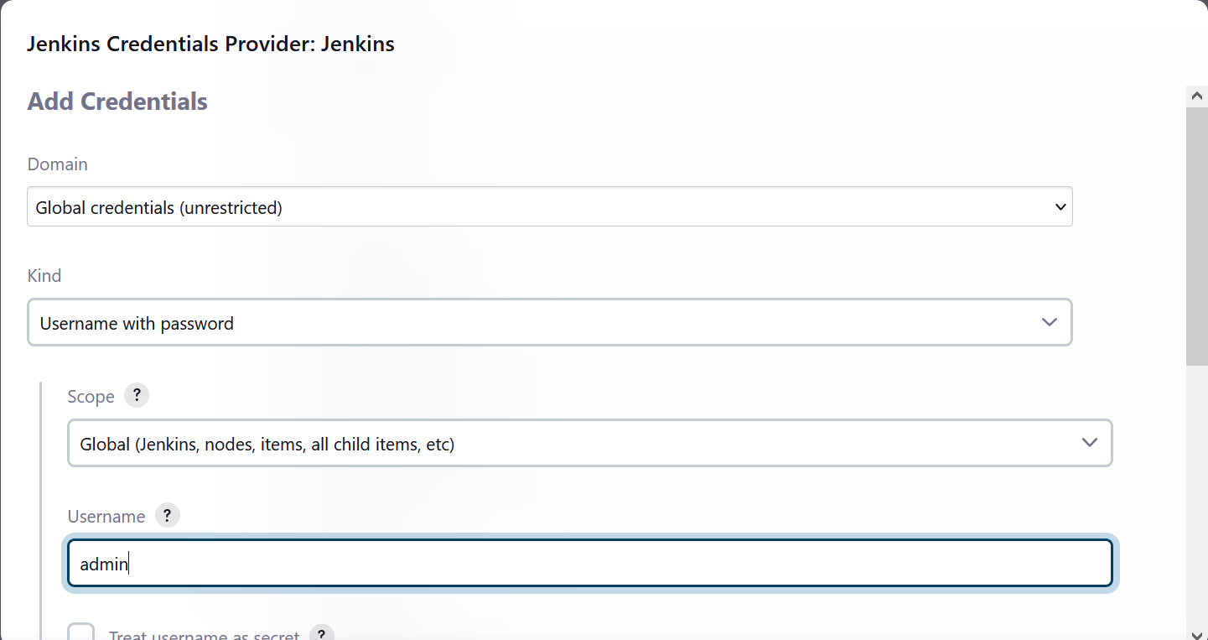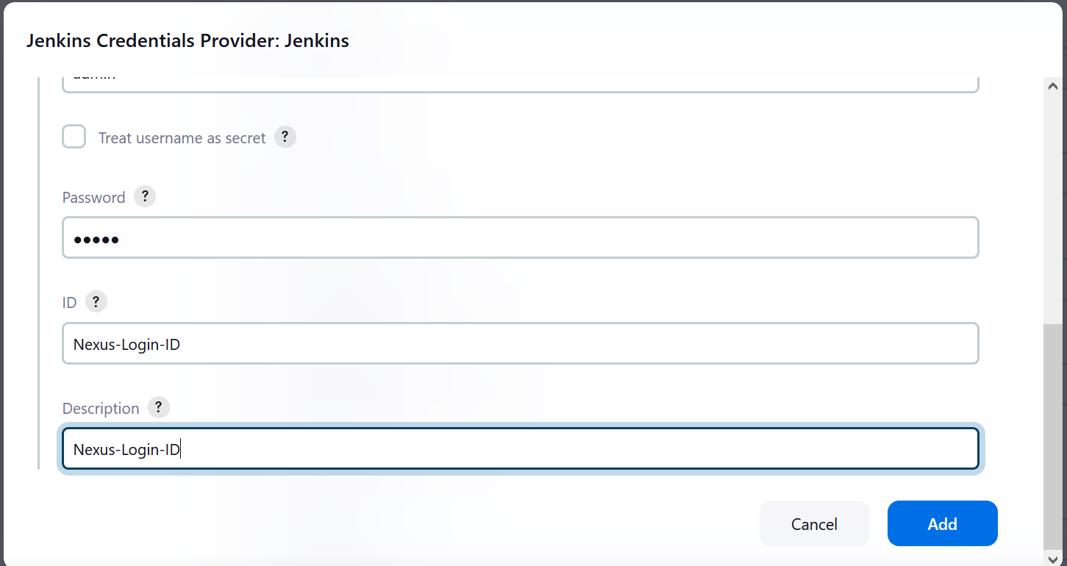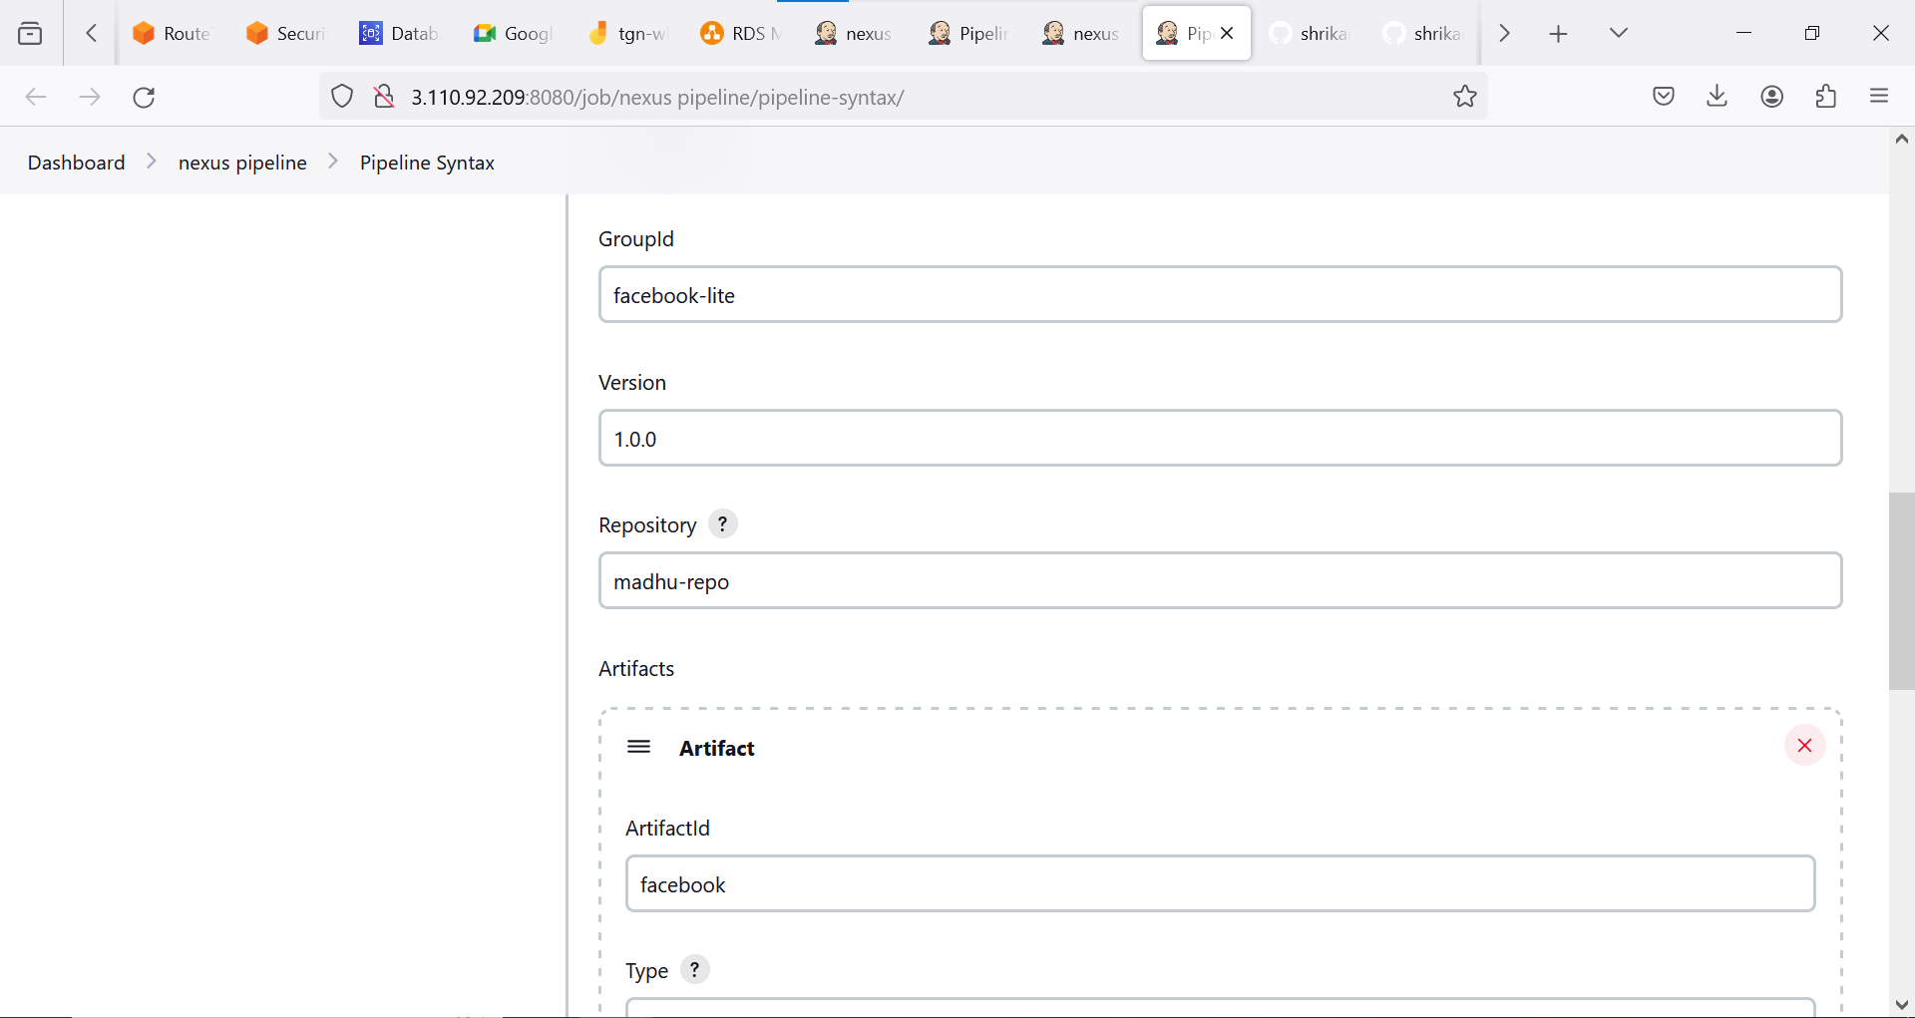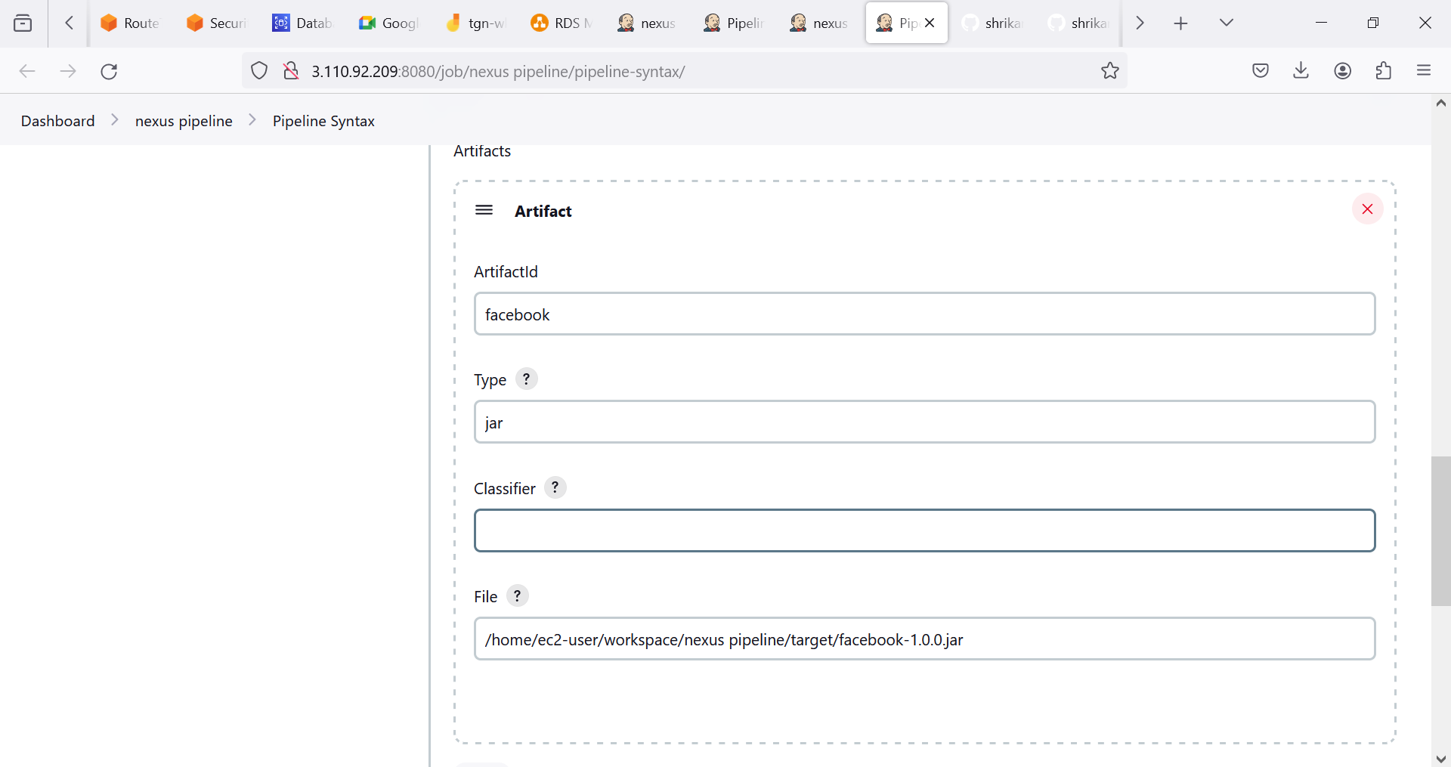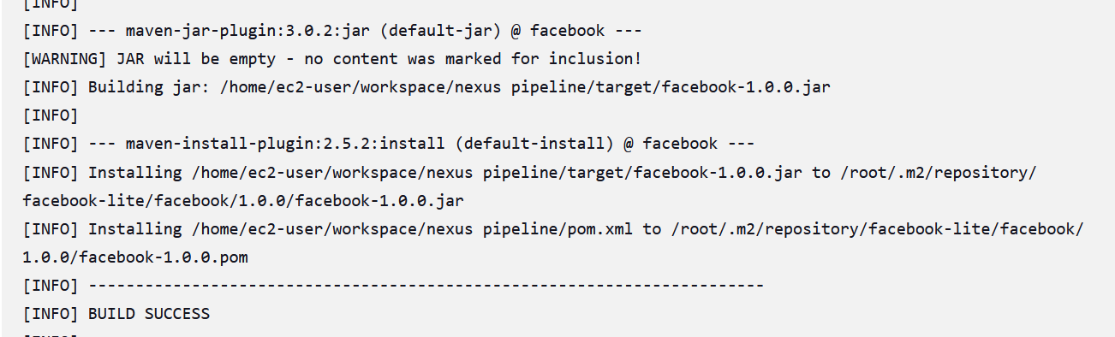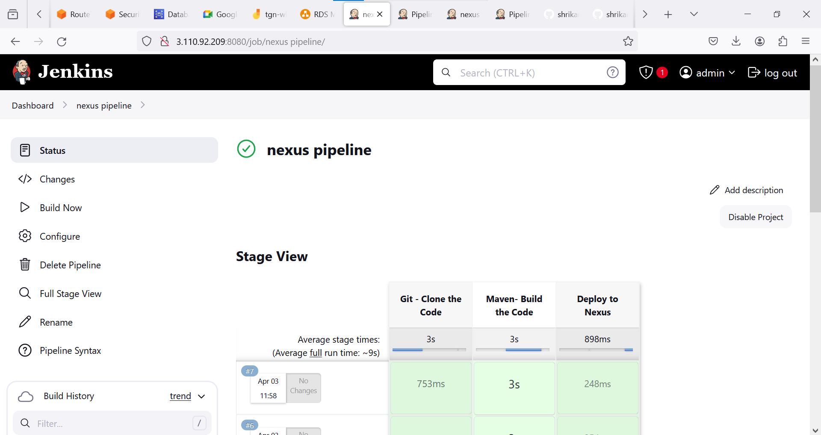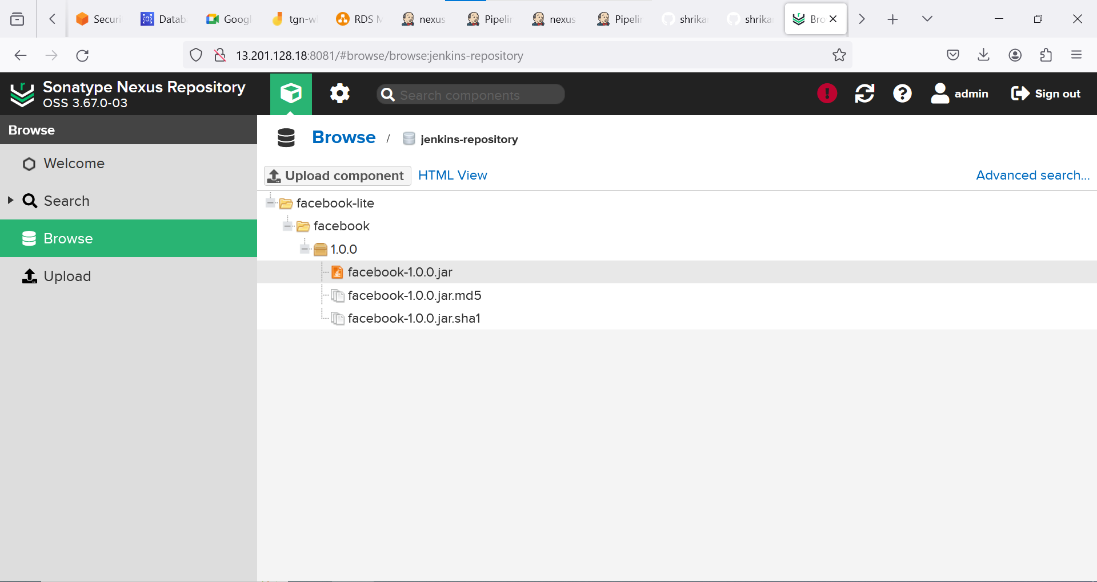

**PIPELINE:**

pipeline {

agent {

label 'slave-1'

}

stages {

stage('Git - Clone the Code') {

steps {

git branch: 'AWS-DEVOPS-BRANCH', changelog: false, poll: false, url: 'https://github.com/shrikanthcr/AWS-DEVOPS-STUDY-MATERIALS.git'

}

}

stage('Maven- Build the Code') {

steps {

sh 'mvn clean install'

}

}

stage('Deploy to Nexus') {

steps {

nexusArtifactUploader artifacts: [[artifactId: 'facebook', classifier: '', file: '/home/ec2-user/workspace/nexus pipeline/target/facebook-1.0.0.jar', type: 'jar']], credentialsId: 'nexus-login-id', groupId: 'facebook-lite', nexusUrl: '13.201.128.18:8081', nexusVersion: 'nexus3', protocol: 'http', repository: 'madhu-repo', version: '1.0.0'

}

}

}

}